

Report
Of
Topic
CISCO PACKET TRACER
Submitted
To
School of Computer Science and Engineering
IILM University, Greater Noida, U.P.
In partial fulfilment of the requirement of degree of
B.Tech CSE
By
Roll Number of Student:25scs1003001266
Name of Student: ADITYA SINGH
Batch: 2cse37
2026-2027
CANDIDATE’S DECLARATION



I, Aditya singh do hereby declare that the internship report titled “Topic” has been completed
by me to fulfil the requirement for the award of the degree of Bachelor of Technology in
CSE. All the references have been quoted and I have not taken as such any material from any
other source. I affirm to you that this report is my own and has not been submitted to any
other institute for any degree/diploma requirement and further I shall be solely responsible
for any kind of copyright violation in this regard.
Signature
Student Name: ADITYA SINGH
Roll No.25SCS1003001266



ACKNOWLEDGEMENT
I am using this opportunity to express my gratitude to everyone who supported me throughout
the Internship Program. I am thankful for their aspiring guidance, invaluably constructive
criticism and friendly advice during this work. I am sincerely grateful to them for sharing
their truthful and illuminating views on a number of issues related to this work.
I express my gratitude to my parents for their blessings.
Signature
Student Name: ADITYA SINGH
Roll No..25SCS1003001266

Chapter No. | Chapter Name | Page Nos.

 | Cover Page | ----

1. | Candidate’s Declaration

2. | Acknowledgment

3. | Internship Completion Certificate

4. | Project Description  4 .1 Introduction  4.2 Organization Profile  4.3 Problem Statement  4.4 Project Objectives  4.5 Scope of the Project  4.6 Technologies and Tools Used  4.7 System Architecture  4.8 Methodology  4.9 Expected Outcomes  4.10 Certificates of completion and other  communication mail proof must be attached

5. | Bibliography/References
4.1 Introduction
This project is based on the design of an enterprise network that can be used for both normal
data communication and voice communication. The network is created and tested in Cisco
Packet Tracer before it can be considered for a real environment.
In the proposed network, different departments are connected through switches and routers.
Computers, IP phones, printers, servers and wireless devices are included so that employees
can access the required services from their department. VLANs are also used to keep the
departments separated and to make the network easier to control.
The main idea of the project is to create a network which is simple to manage, reliable for
daily use and flexible enough for adding more users or devices in the future.

4.2 Organization Profile
For this project, the organization is considered as a medium-sized company with several
departments. The main departments included in the network are Sales, Administration and
Engineering. There is also a management and server section where important network
resources are located.
Employees | in | each | department | need | access | to | computers, | printers, | servers | and
communication facilities. Some users may also require wireless access while moving around
the workplace.
Since all these departments have different requirements, the company needs a properly
planned network instead of connecting every device to one common network. The proposed
design provides separate network sections while still allowing communication between
departments when required.
4.3 Problem Statement
A growing organization can face different networking problems when its infrastructure is not
properly planned. When all computers and devices are placed in the same network, broadcast
traffic can increase and it becomes harder to manage the users and resources.
Another issue is communication. Modern organizations usually need both data and voice
services. Using separate infrastructures for every service can increase the cost and make the
network more difficult to maintain.
The main problem addressed in this project is therefore to create a network that can support
data, voice and wireless communication while keeping different departments properly
separated. The network should also allow authorized communication between departments
and provide access to common resources such as servers and printers.
4.4 Project Objectives
The main objectives of this project are:
1. To design an enterprise network using Cisco Packet Tracer.
2. To provide communication between different departments.
3. To separate departments using VLANs.
4. To provide both wired and wireless network access.
5. To include IP phones for voice communication.
6. To provide shared printers and server resources.
7. To configure routing between required networks.
8. To provide suitable network security and management.
9. To provide external network connectivity.

10. To test the network and identify possible configuration problems.
4.5 Scope of the Project
The project covers the design and simulation of an enterprise network using Cisco Packet
Tracer. It includes the basic network infrastructure required by a medium-sized organization.
The scope includes switches, routers, computers, IP phones, printers, servers, wireless access
points and network controllers. VLANs are created for the different departments and IP
addressing is used to identify the devices and network segments.
The project also covers switching, routing, wireless connectivity, voice communication and
basic network management. After the configuration is completed, connectivity tests are
performed to check whether the devices can communicate correctly.
The project is mainly focused on simulation and does not include the physical installation of
networking equipment in an actual company.
4.6 Technologies and Tools Used
Cisco Packet Tracer is the main software used for designing and testing the network. It
provides a simulation environment where routers, switches, computers, servers and other
networking devices can be configured.
The main technologies used in the project are:
• Ethernet networking
• VLAN
• IPv4 addressing
• Switching
• Inter-VLAN routing
• Wireless networking
• IP telephony
• DHCP and other server services
• Network security
• Network management
Cisco switches are used to connect the end devices, while routers or Layer 3 switches are
used to provide communication between different networks. Cisco IP phones are included
for voice communication. Wireless access points provide wireless connectivity to users.

4.7 System Architecture
The proposed system follows a structured enterprise network architecture. The network
contains several departments along with a centralized server and management area.
The main sections of the network are:
• Sales Department
• Administration Department
• Engineering Department
• Management and Server Network
• Wireless Network
• External Network
VLANs are used to separate the departments logically. The VLANs used in the design are:
VLAN | 15 | - | Sales

VLAN | 20 | - | Administration

VLAN | 30 | - | Engineering
VLAN 50 - Management/Server Network
The Administration network uses the gateway address 192.168.2.1 and the Engineering
network uses 192.168.3.1 as shown in the proposed topology. These addresses should be
checked with the final Packet Tracer configuration before submission.
The basic communication flow can be represented as:
End Device →Switch →Gateway/Router →Destination Network →Destination Device
The server section provides centralized resources, while wireless access points allow mobile
users to connect to the network. IP phones use the IP network for voice communication.
Figure 1: Enterprise Network Topology
Insert the Cisco Packet Tracer topology screenshot here.
4.8 Methodology
The project was developed in several stages. First, the requirements of the organization were
considered and the departments and required devices were identified.
After this, a suitable network topology was planned. The required switches, routers,
computers, servers, IP phones, printers and wireless devices were selected according to the
proposed design.

The next step was creating the VLAN structure. Each department was given its own VLAN
so that the network traffic could be separated. An IP addressing plan was then prepared for
the different networks.
After planning, the complete topology was created in Cisco Packet Tracer. Devices were
connected and basic configurations were applied. VLANs, IP addresses, routing and wireless
settings were configured. IP phones and other services were also added according to the
requirements.
Finally, the network was tested using ping and Cisco IOS commands. If a device could not
communicate correctly, the configuration was checked and the problem was corrected. This
helped to verify that the final network was working as expected.
4.9 Expected Outcome
The expected result of this project is a properly functioning enterprise network that can
handle both data and voice communication.
Each department should have its own logical network through VLANs, while routing should
allow communication between the networks where it is permitted. Users should be able to
access shared resources such as servers and printers.
The wireless part of the network should provide connectivity for mobile users, and the IP
phones should support communication through the network.
The completed design should also be reasonably easy to expand. More computers, phones,
access points or even new departments can be added without completely changing the
existing network structure.
Successful ping tests, routing checks and other verification commands in Cisco Packet Tracer
will be used to confirm that the network is operating correctly.
+ 1. Conclusion
This project presents the design of a converged enterprise network that supports data, voice
and wireless communication. The proposed infrastructure connects different departments
while using VLANs to keep their traffic logically separated.
The network includes switches, routers, computers, servers, printers, wireless devices and IP
phones. Routing allows communication between the required networks, while centralized
services make common resources easier to access and manage.
Cisco Packet Tracer was useful for building and testing the design before a real
implementation. The project also shows that proper planning of IP addressing, VLANs,
routing, security and testing is important for creating a reliable enterprise network.

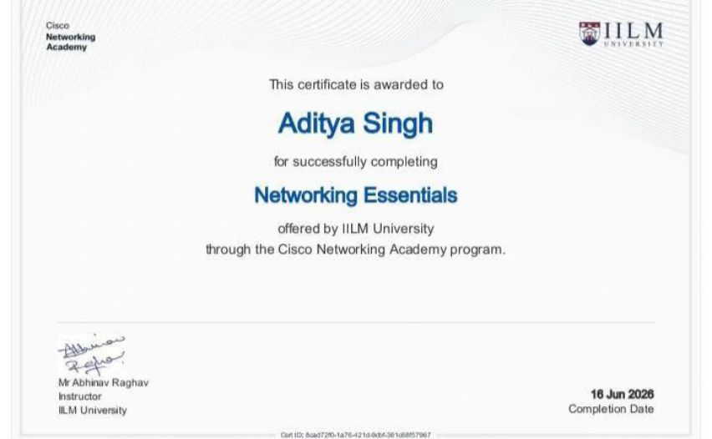

References
1. Cisco Networking Academy, networking fundamentals and switching materials.
2. Cisco Packet Tracer documentation and learning resources.
3. Cisco IOS configuration and command reference materials.
4. Computer Networking: A Top-Down Approach, networking concepts and protocols.
5. TCP/IP networking and IPv4 addressing reference materials.
6. Course notes and laboratory materials related to VLANs, routing, wireless networking
and IP telephony.
7. Cisco documentation related to enterprise switching, routing and network security.







This certificate is awarded to
Aditya Singh
for successfully completing
Exploring Networking with Cisco Packet Tracer
offered by IILM University
through the Cisco Networking Academy program.
Mr Abhinav Raghav
Instructor 16 Jun 2026
IILM University Completion Date
Cert ID: cce3560b-3889-4eb7-8242-326faaec5cd1







This certificate is awarded to
Aditya Singh
for successfully completing
Getting Started with Cisco Packet Tracer
offered by Networking Academy
through the Cisco Networking Academy program.
Lynn Bloomer
Director 11 Aug 2026
Cisco Networking Academy Completion Date
Cert ID: e55e46b0-513b-4c30-823f-9c6283a1cac7

